1. Enter below United Health Dental link in Chrome browser

<https://www.uhc.com/find-a-physician>

1. Click on **Dentist** appearing under the list **What kind of provider are you looking for?**

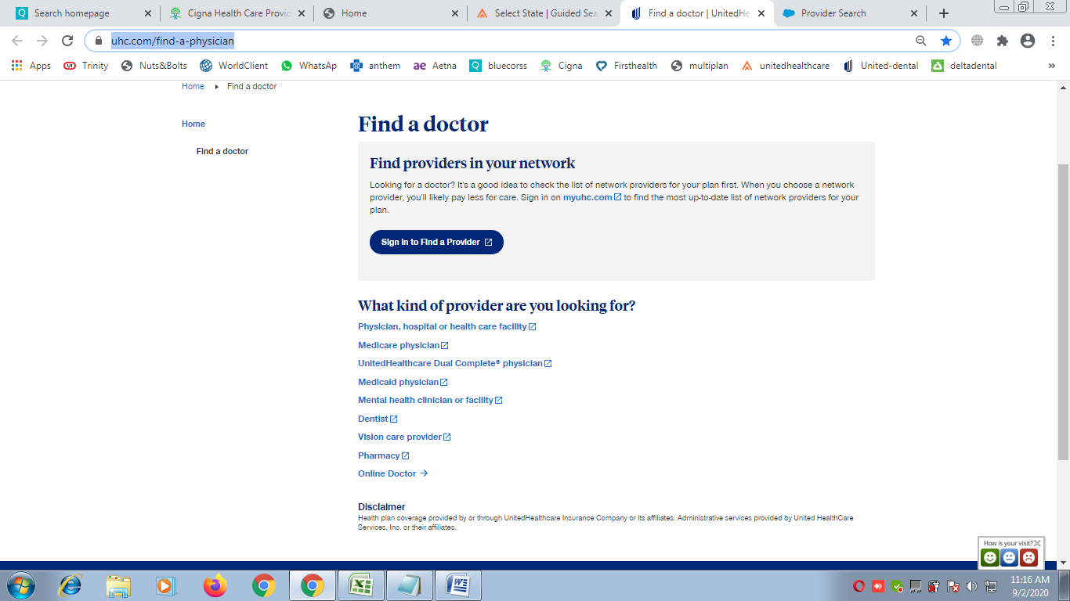

1. Clicking on Dentists a new tab would open with this link: <https://dentalsearch.yourdentalplan.com/providersearch>
2. Select Dentist Name option, Enter Last Name First Name, Enter state and then click on Search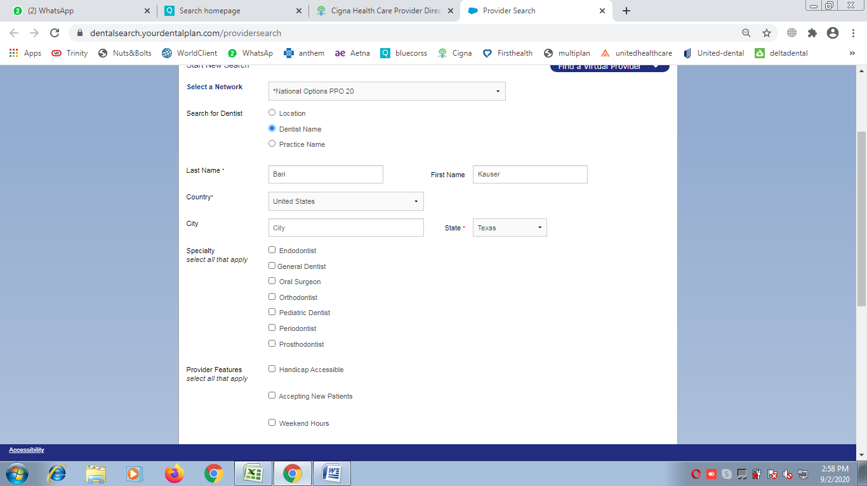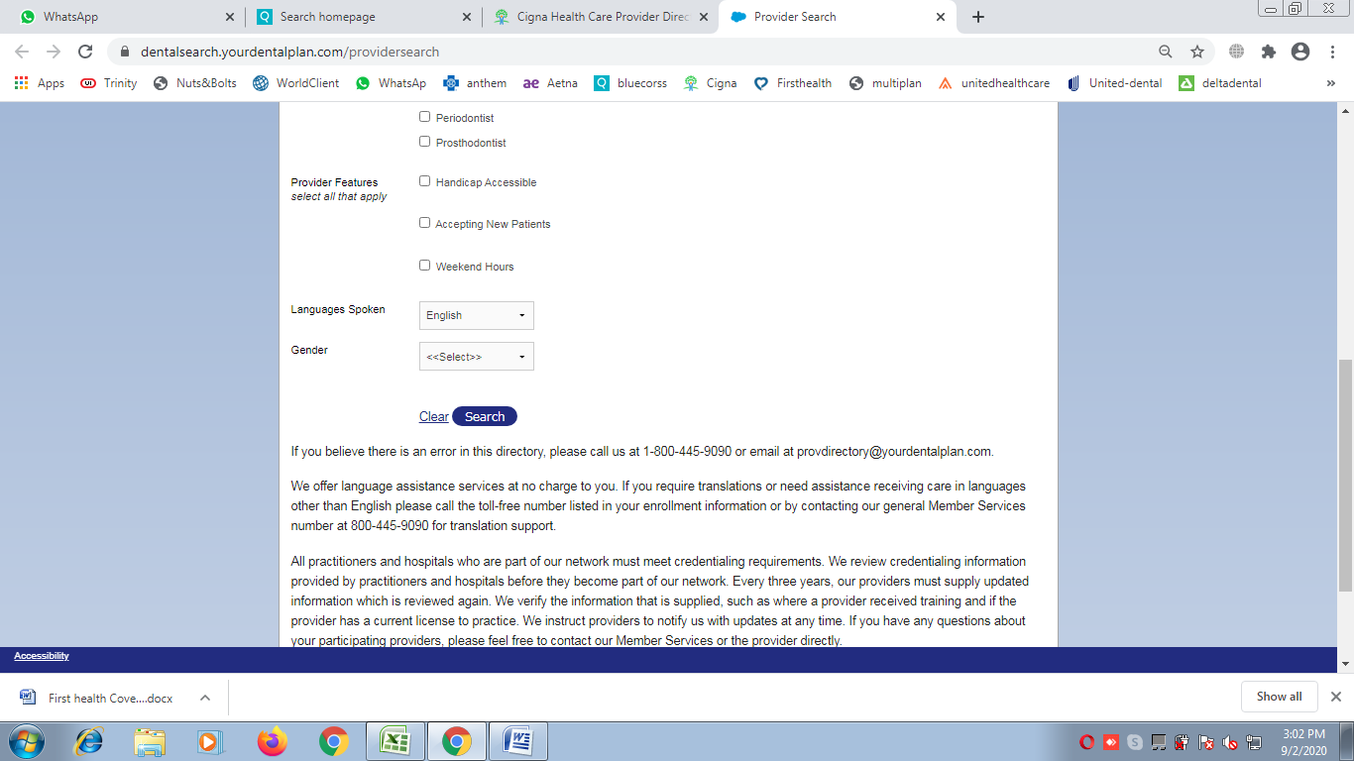
3. If provider found enter “**Yes”** in R column of excel

